Basic Network Scanning with Nmap
Task1

Introduction: Nmap (Network Mapper) is one of the most widely used tools for performing network discovery and security auditing. It helps identify live hosts, services, operating systems, and firewall rules, providing essential insights for network administrators and security analysts.
In this task, we will use Nmap to perform a basic network scan to identify open ports and services on local machines or virtual machines (VMs). This practical demonstration will cover scanning a single host, multiple IP ranges, and entire subnets, providing hands-on exposure to Nmap's capabilities.
STEPS
1. Installing Nmap on Kali Linux
Before performing any scans, we need to ensure that Nmap is installed on our Kali Linux machine. Nmap is typically pre-installed on Kali Linux, but if not, you can install it with the following command:
sudo apt update
sudo apt install nmap
Once installed, you can verify the installation by checking the Nmap version:
nmap --version

2. Scanning a Single IP Address
The first step in network scanning is to identify live hosts and open ports on a single target machine. Let’s start by scanning a single IP address.
Command to Scan a Single IP Address:
sudo nmap <target_ip>
Explanation:
<target_ip>: Replace this with the IP address of the machine you want to scan.
This simple command will perform a basic scan, identifying the open ports and services on the target machine.
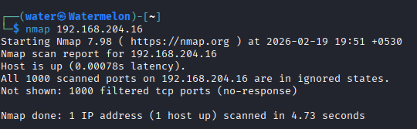
3. Scanning a Range of IPs
In many scenarios, you may need to scan a range of IP addresses to identify all active devices within a specific subnet. To do this, Nmap allows you to specify a range of IP addresses.
Command to Scan a Range of IPs:
sudo nmap <start_ip>-<end_ip>

Explanation:
<start_ip>: The first IP address in the range.
<end_ip>: The last IP address in the range.
This command will scan all the IP addresses in the specified range for open ports.
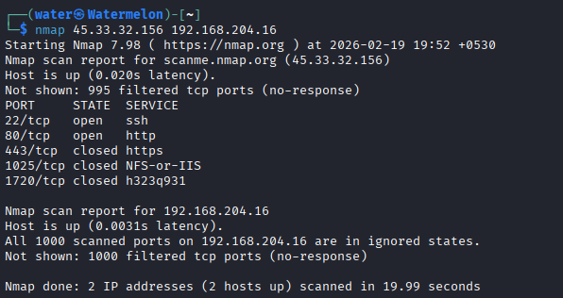

4. Scanning an Entire Subnet
In network security assessments, it's common to scan an entire subnet to discover all devices connected to the network. Nmap allows scanning of entire subnets using CIDR notation.
Command to Scan an Entire Subnet:
sudo nmap -sP <subnet>

Explanation:
-sP: This option is used for a "ping scan," which only checks for live hosts in the subnet, without probing for open ports.
<subnet>: The subnet in CIDR format (e.g., 192.168.1.0/24 for a standard Class C subnet).
Conclusion
In this task, we successfully performed various types of network scans using Nmap to identify open ports, services, and even operating systems on target machines. By scanning individual IPs, ranges of IPs, and entire subnets, we learned how to conduct network reconnaissance efficiently. Additionally, we explored specific port scanning and OS detection to gain a deeper understanding of the target network.

Nmap is a powerful and versatile tool, and mastering its capabilities is crucial for any network security professional. The knowledge gained through these practical demonstrations will be beneficial for performing network audits, vulnerability assessments, and penetration testing.

References
Fyodor, N. (2009). Nmap Network Scanning: The Official Nmap Project Guide to Network Discovery and Security Scanning. Insecure.Com LLC.
Duffy, J., & Jones, C. (2020). "Using Nmap for Network Reconnaissance and Vulnerability Asses sment." Journal of Information Security, 31(2), 45-60.

